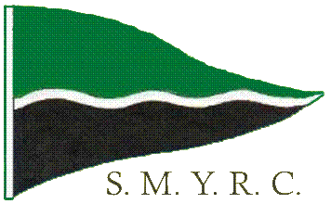

Stirling Marblehead Yacht Racing Club Inc (SMYRC) Membership Form
Member Information

Current membership is $40 per annum which includes an affiliation with the state and national associations. It also includes insurance against third party claims.
If you are already a member of another SA Radio Yacht Club then the membership is $22.

Family Name: Preferred Name: Partner’s Name:

Address: City/Town/Suburb: State: Post Code:

Phone: Mobile: E-mail:

Previous sailing experience:

Note:

Yacht Information
Yacht type may be Marblehead, One Metre, Ten Rater, etc. Indicate ‘Y’ or ‘N’ for wether the yacht is measured

Yacht Type | Sail Number | Yacht Name | Measured (Y/N)

Radio Information
The 3 bands are 29 MHz, 36MHz, and 2.4GHz. No channel number or frequency is needed for a 2.4GHz set (Spektrum etc) Only complete priority 2/3 if you use more than one radio

Band | Channel | Frequency

Please complete the form and return to the secretary Ben Morris at Woorabinda or complete the on-line membership form on the club website at http://www.stirling.saradioyachting.org.au and select the ‘Membership’ page from the top menu.
Lake Woorabinda:

Lake Woorabinda was constructed in the 1920’s to serve as a source of water for the steam trains running through the Adelaide Hills.

It is now a very popular area for locals to exercise their dogs or to walk through the park.

The area houses an Environmental Education Centre home of the Onkaparinga Waterwatch Network Group and is used by a number of groups including Conservation Volunteers Australia and Trees for Life for training sessions and workshops.

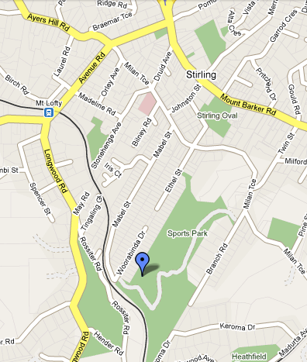

Lake
Woorabinda

Stirling Marblehead Yacht Racing Club Inc

About our club:

The Stirling Marblehead Yacht Racing Club meets every Wednesday from 10:30 a.m. to 3:30 p.m. where radio controlled Marblehead yachts race on Lake Woorabinda.

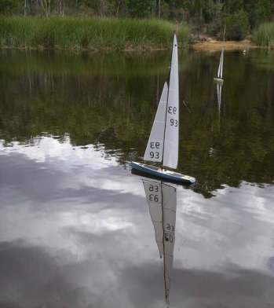

With their tall rigs and the attractive surrounds of Lake Woorabinda, the Marbleheads make a striking scene at one of the most attractive r/c sailing venues in the state.

Marblehead Yachts:

A Marblehead yacht is about 1.29 metres in length with a 2 metre mast carrying just over ½ square metre of sail area. This makes for a fast and efficient yacht. Yachts are radio controlled and usually have steering and sail adjustment capabilities.

New members are most welcome and the club owns a yacht which is available to use until they can organise their own yacht.

Many members have built their own yachts or at least completed the fitting out and rigging. They are always prepared to assist others. It is also possible to purchase second hand yachts or even new ones though this can be somewhat expensive.

The yachts are quite sophisticated. The hulls are often constructed of carbon fibre or Kevlar with masts made of carbon fibre. The sails are made like those in full sized yachts with shaped seams giving the sails a very efficient airfoil section. The most common material for sails is Mylar film which is extremely strong and light weight. The winch which pulls in and releases the sails is also a key component of the yacht. We are fortunate in SA to have a world standard sail winch made locally at Angaston.

Contact details:

Commodore: Jeff Gerrard
ph: 0885362711
E-mail: jgerrard@activ8.net.au

Secretary: Ben Morris
Mob: 0424364428
E-mail: benmorris@senet.com.au

Web Site: http://www.stirling.saradioyachting.org.au

