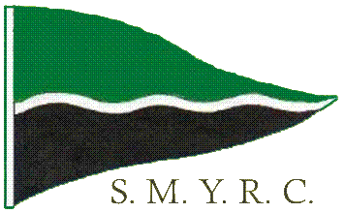

Stirling Marblehead Yacht Racing Club Inc (SMYRC) Membership Form
Member Information

Current membership is $40 per annum which includes an affiliation with the state and national associations. It also includes insurance against third party claims.
If you are already a member of another SA Radio yacht club then the membership is $22.

Family Name: Preferred Name: Partner’s Name:

Address: City/Town/Suburb: State: Post Code:

Phone: Mobile: E-mail:

Previous sailing experience:

Note:

Yacht Information
Yacht type may be Marblehead, One Metre, Ten Rater, etc. Indicate ‘Y’ or ‘N’ for wether the yacht is measured

Yacht Type | Sail Number | Yacht Name | Measured

Radio Information
The 3 bands are 29 MHz, 36MHz, and 2.4GHz. No channel number or frequency is needed for a 2.4GHz set (Spektrum etc) Only complete priority 2/3 if you use more than one radio

Band | Channel | Frequency

Please complete the form and return to the secretary Ben Morris at Woorabinda or complete the on-line membership form on the club website at http://www.stirling.saradioyachting.org.au and select the ‘Membership’ page from the top menu

